Hammond L100 Upper Manual Chassis Removal
For the purpose of adding Foldback
Copyright © 2010-2019 Alan P. DuBois
(Rev. 04/2019)

This documentation is to accompany the foldback kits I have available on eBay.
To find my kits, search for “Hammond Foldback” on eBay.

Note: The number and the type of fasteners as well as the location/style of some components will vary depending on the vintage and/or Model of the unit you are working on. The following is based on L111 chassis removal. NOTE: Some of the photos herein are not as sharp as I thought. I’ll post some better photos in the future!

1. Unscrew and remove the cover from the back of the organ.

2. Remove top wood cover (with music rack attached) by removing the two screws at the rear and then pulling up on the front of the top cover until it pops out. NOTE: Models and fasteners may vary! NOTE: Some models may have four (4) screws!

3. With the top cover removed, remove the metal, L-shaped tablet cover by removing two screws at top (one at each end) and two screws at rear (one at each end). There are three retaining clips which also hold the front of the L-shaped cover to the tablet chassis. You need to pull the L-shaped cover rearward to detach the cover from these clips. Wedging a screwdriver tip between the clips and the cover will aid in removing it.

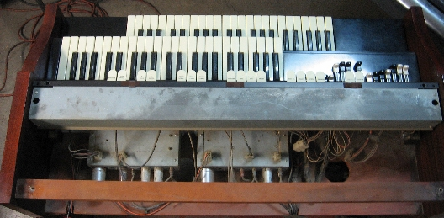
4. Separate the two 9-pin connectors at both the upper and lower manual chassis

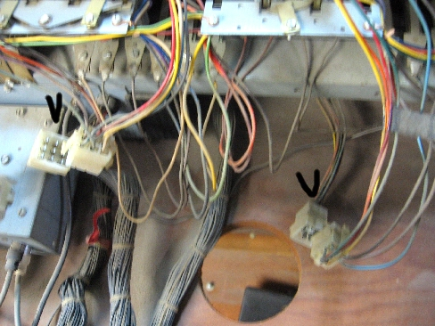

5. Remove the screw holding the connector for two Ground leads from the upper chassis.

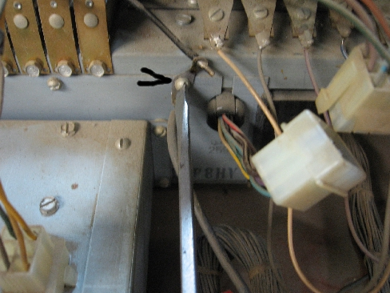

6. Detach the Vibrato and Percussion preamps from the upper chassis by removing the four (4) screws on each of the preamps and let the preamps rest on the wood shelf.

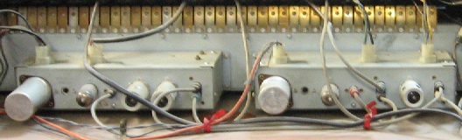

7. Loosen any wire ties holding the tone generator wiring to the wood shelf.

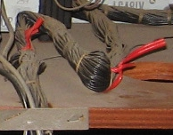

8. Remove the two screws holding the Pedal can (click-filter, whatever you want to call it) and one Ground lead and lay them down on the shelf. NOTE: Your filter may or may not look like the one pictured.

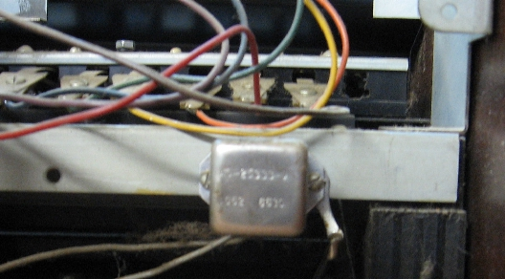

NOTE: Before proceeding, place a cloth or some cardboard between each end of the tablet assembly and the wood case to avoid scratching the wood finish

9. Remove the slotted, hex-head screws from the tablet assembly (one screw at each end).

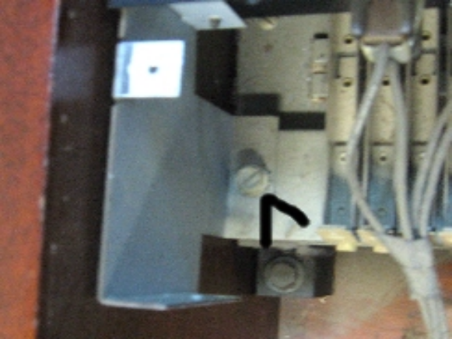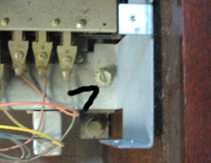

10. While exercising caution, move the tablet assembly toward the front of the organ just enough to allow clearance to the two (2) hex-head screws holding the rear of the drawbar assembly. Remove the two screws. Then move the tablet assembly toward the rear and remove the two (2) hex-head screws retaining the front of the drawbar assembly.

11. Have someone assist you with the following: Carefully raise the entire tablet assembly WITH the drawbars, rotating both assemblies upside-down toward the rear of the case. Secure the tablet assembly and drawbars to the upper wood crossmember using string or whatever you have available. If you don’t secure these items, they may simply fall out of the back of the organ, and you don’t want that to happen!

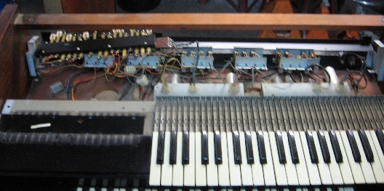

12. At each end of the Upper manual chassis, remove the hex-head bolts holding the rear of the upper manual chassis to the case.

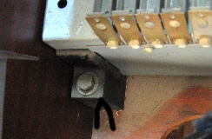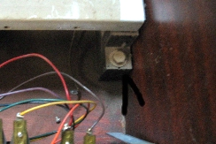

13. Now, at frontside of the organ, underneath, remove the two screws holding the upper manual chassis to the case (one screw at each side, left side shown).

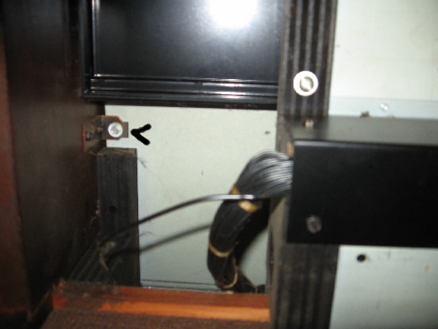

NOTE: Before proceeding, slip some cloth or other protective material between the ends of the chassis so you don’t damage any of the finished wood surfaces!

14. Carefully tilt the upper manual chassis rearward to a vertical position. Use some wood blocks as shown and block it in place at each end against the rear crossmember.

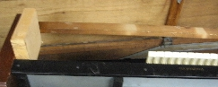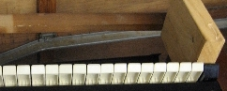

15. At the bottom left end of the upper chassis, pry away the metal retaining clip for the wiring harness.

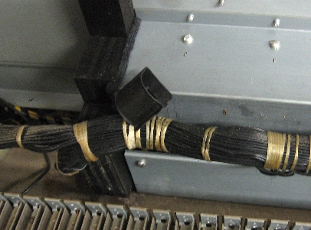

16. Now desolder all of those wires from the upper manual chassis. If no one has previously messed with the wiring harness, there should be string loops over every contact wire - in order - so that you will know exactly where to reinstall all the wire leads when you reinstall the chassis. WARNING: If the terminals are mounted to a Black, plastic board, DO NOT OVERHEAT THE TERMINALS when desoldering/soldering! Overheating will melt the plastic and the terminals will simply fall away from the board! Take care!

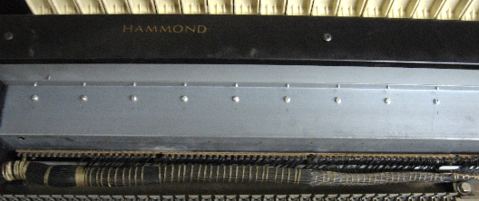

17. You should now be able to lift the upper manual chassis out of the organ case - taking care not to scratch the wood surfaces.

18. Remove all the playing keys. To do so, at rear of chassis, loosen all the hex-head key mounting screws at least one turn. Do not remove the screws. Lift the rear of key off the mounting screw then slide key slightly rearward and then lift out the key. NOTE: Black keys must be removed before removing the adjacent white keys. NOTE ALSO: It is suggested to set the keys aside in the same order as they were fitted in the chassis.

Install chassis in reverse order of removal

